*Poll Everywhere software to embed the poll into the powerpoint*.

<http://doc.gold.ac.uk/~aelza001/DDI/app/mainbuttons.html>

**Powerpoint example of our walkthrough project for last year:**

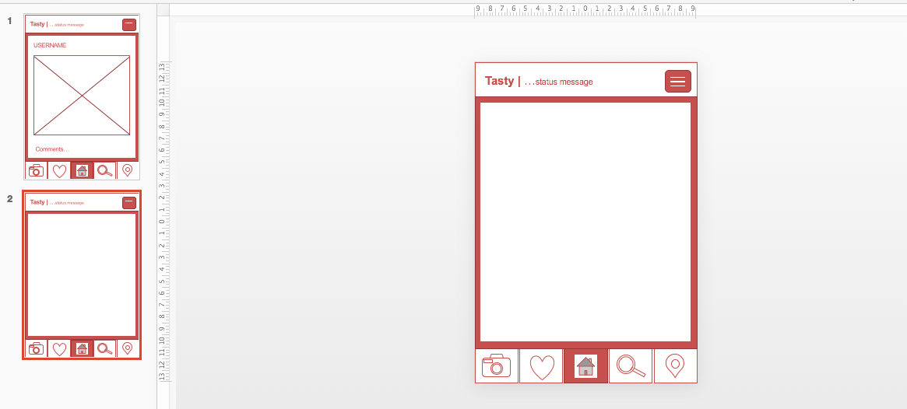

**Project survey questions**

**Features of the website**:

Location : do we need to track location of the users at any point?

Decide on names: List the names at the beginning then at the end ask again to decide on one name.

Rating section: How would you like the rating system to be?;;;p;

Would you rather see the map or a swipe option or even both?

**User feedback:**

Do you like the idea?

Would you use it?

How often would you use the app?

Do you know anyone who would benefit from the app (such as relatives)?

**Payment and trust**

Would you pay for it?

Would you pay via PayPal?

Would you pay via cash?

Would you pay via card?

Is there a way for students to raise an issue with payment?

Would the students rather contact us or straight away contact the parents?

What kind of information should we reveal until actual phonecall is made.

**Usability**

How user friendly is it?

Where the buttons too small?

Colour Scheme?

What could be improved?

Parents prototype:

* Aaron
* Zin
* Ali
* Coreen

Student prototype:

* Fahim
* Aman
* Ali
* Coreen

Competitor screenshots for colour scheme ideas

